**Station A**

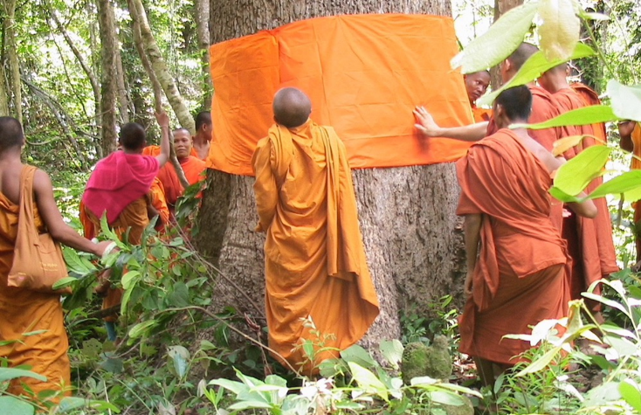______________________________________________

______________________________________________

______________________________________________

______________________________________________

______________________________________________

______________________________________________

______________________________________________

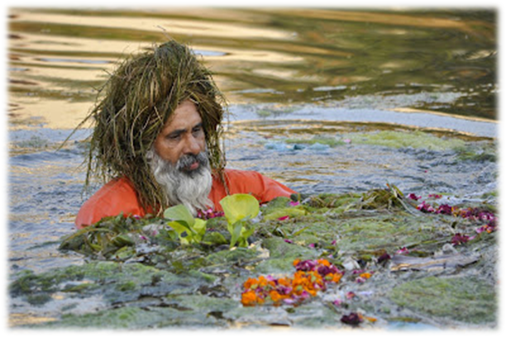**Station B**

_____________________________________________

_____________________________________________

_____________________________________________

_____________________________________________

_____________________________________________

_____________________________________________

_____________________________________________

_____________________________________________

**Station C**

_____________________________________________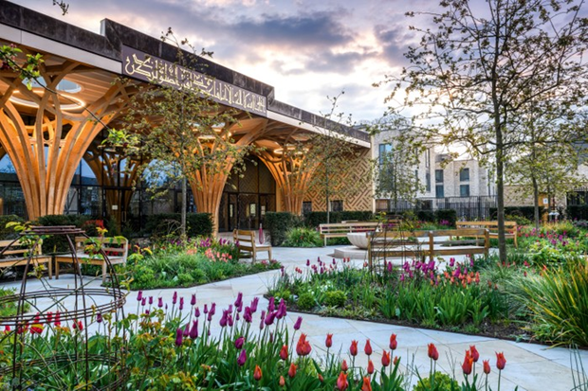

_____________________________________________

_____________________________________________

_____________________________________________

_____________________________________________

_____________________________________________

_____________________________________________

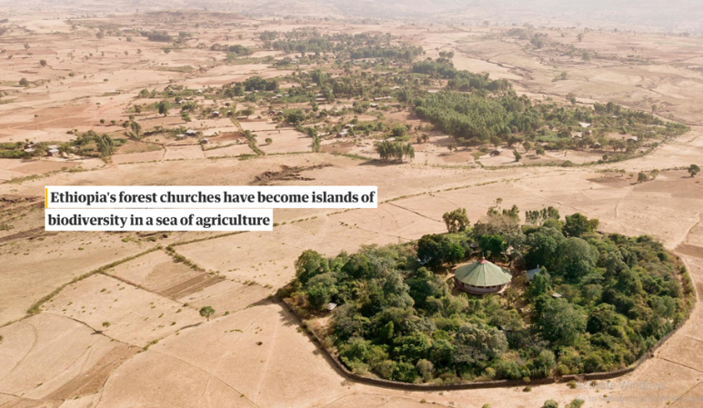**Station D**

____________________________________________

____________________________________________

____________________________________________

____________________________________________

____________________________________________

____________________________________________